**TASK1**- Priyanshi Surana

**E-MAIL** : priyanshisurana0129@gmail.com

**Q1. When we create a user some hidden files are generated in the directoty of the same user at that time. How is it done ?**

**Ans:-**

The **/etc** directory and its subdirectories contain so many important configuration files for the system.

So, **/etc/shel allows a system administrator** to create a default home directory with some important hidden files for all the new users on a computer to make them begin with the same settings or environment . Therefore these hidden files are generated automatically at the time of new user creation.

**Q2. Make sub directories inside a parent directory by using single mkdir command (refer figure given below)**

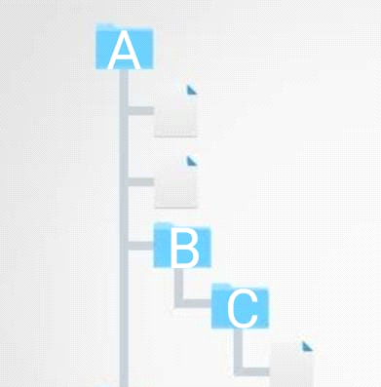

**Ans :-**

mkdir -p A/{B/{C}}

//p is used to describe the parent directory//

**Q3. When we create a new user using "useradd" command ,it does not make a user name directory in the /home automatically . Why?**

**Ans : -**

**"useradd"** command is a low level utility command for adding users **.** To be able to use the **useradd** command and create new users you need to be logged in as root or a user with **sudo** access.**WHILE**

**"adduser"** is a high level tool which chooses by default Debian Policy Conformant UID and GID values,creating a home directory with skeletal configuration running a custom script and other features.